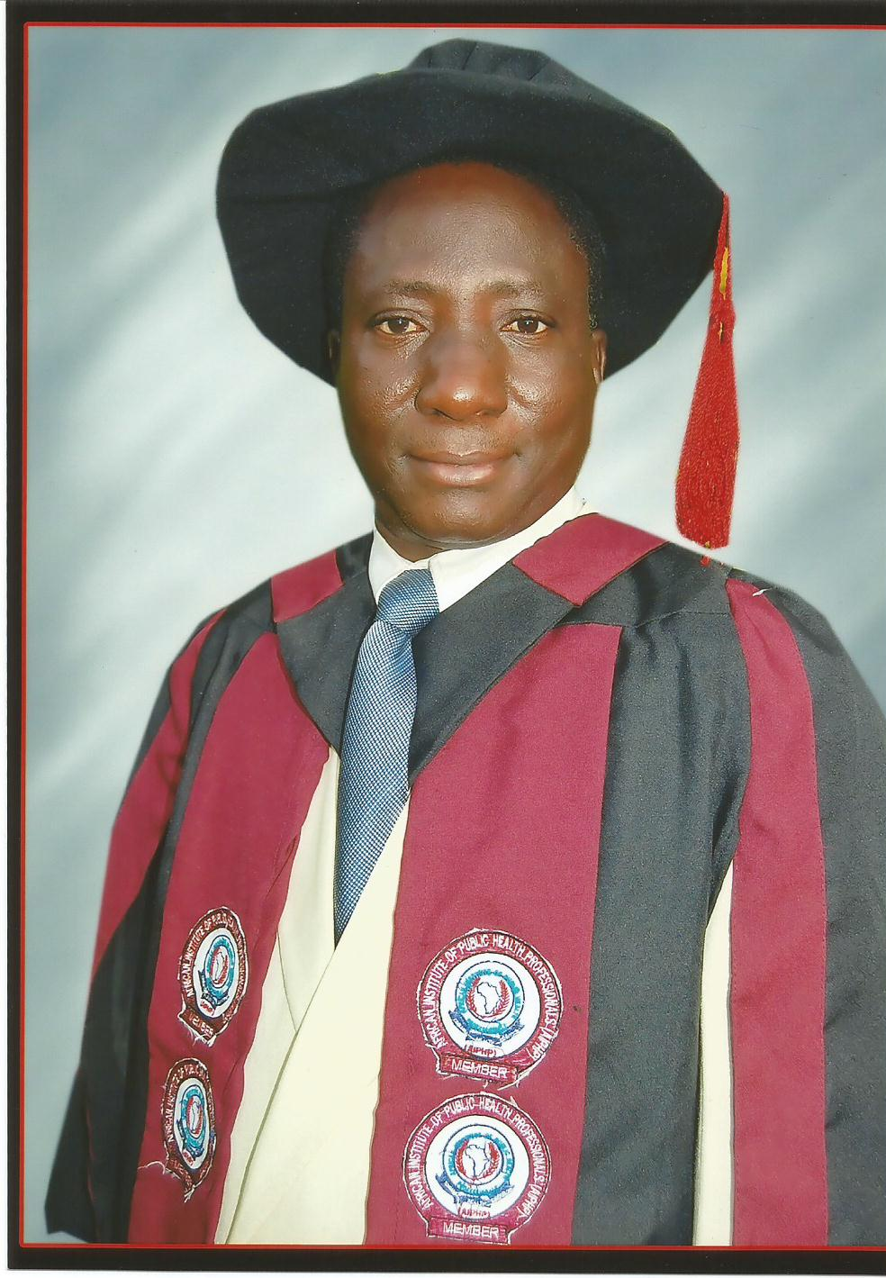

ADEYEMI, Titus Friday(mcia; faiphp; mnacch)
CHA; CHO; B.SC HEALTH (EDU); Dip in Edu;
(PHC) Tutor; Cert. In DP & MIS; MPH; MCIPM; MPA; RCHP.
Ph.D in-Progress

CURRICULUM VITAE

- FULL NAME:
ADEYEMI, Titus Friday.
2. PLACE AND DATE OF BIRTH:
Isanlu-Yagba East, 15th March, 1959.
3. STATE OF ORIGIN:
Kogi State.
4. PERMANENT HOME ADDRESS:
Late Pa Aaron Oshagbemi Alege’s House,
Ayinose Compound, Okebukun Mopo,
Isanlu-Yagba East Kogi-State.
5. PRESENT CONTACT ADDRESS:
I/C Mrs. Tayo Adeyemi,
School of Post Basic Nephrology Nursing,
UITH School’s Complex, (Old Maternity Wing).
Amilegbe Street,
P.M.B. 1459.
Ilorin, Kwara State
6. MARITAL STATUS:
Number and Ages of Children:
Married with Four Children
28, 25, 21 and 15 years respectively
7. PROFESSIONAL REGISTRATIONS/LICENSE
Reg. No. 013819. Valid till August 2019

8. MOBILE TELEPHONE NUMBERS
  - MTN - 08060134943
  - GLO - 08058279200
  - AIRTEL - 08081581002
  - ETISALAT- 08174242840
9. E-MAIL ADDRESS:
titusfriday@gmail.com

10. CAREER PATH
Community Heath Asst. GL 05 Step 01 1987
Snr. Comm. Health Asst. HATISS 5 1992
Principal Comm. Health Ext. HATISS 6 1999
Chief Comm. Health Asst. HATISS 7 2002
Comm. Health Care Tutor CONTISS 8 2005
Snr. Comm. Health Care Tutor CONTISS 9 2008
Principal Comm. Health Care Tutor CONHESS 11 2011
Assist Chief Comm. Health Care Tutor CONHESS 12 2014 Chief Comm. Health Care Tutor CONHESS 13 2018
11. CURRENT POST HELD:
Chief Community Health Officer Tutor.
12. CURRENT REMUNERATION:
CONHESS 13 STEP 01

13. EDUCATIONAL INSTITUTIONS ATTENDED
- Ladoke Akintola University of Technology, Ogbomoso 2015-2016
- University of Ilorin, Ilorin Kwara State. 2013-Date
- Obafemi Awolowo University, Ile-Ife Osun State. 2009- 2011
- University of Ilorin, Kwara State. 2007
- University College Hospital (UCH) Ibadan-Oyo State 2003-2004
- University of Ado-Ekiti, Ekiti State. 2000-2003
- College of Health Technology, Zawan-Plateau State 1997-1999
- The West African Examination Council (G.C.E). 1996
- School of Health Technology, Offa-Kwara State 1983-1985
- St. Kizito’s College, Isanlu-Kwara State 1975-1980
- ECWA/LSB, Mopo-Isanlu, Kwara State 1969-1974

14. ACADEMIC AND PROFESSIONAL QUALIFICATION
  - Master in Public Administration (MPA) 2016
  - Ph.D in Epidemiology and Community Health (In Progress)
  - Master of Public Health (MPH)
Health Management as Area of Specialization. 2011
  - Certificate in Data Processing and Management
Information System (CDPMIS) 2007
  - Diploma in Education (Primary Health Care) Tutor. 2004
  - Bachelor of Science in Health Education ( B.SC ) 2004
  - Diploma in Community Health Officers (CHO) 1999
  - Senior School Certificate Examination (G.C.E) 1996
  - Certificate for Community Health Assistant (C.H.A) 1985
  - The West African School Certificate (W.A.S.C) 1980
  - Certificate/Testimonial of Primary School
Education 1974
15. TEACHING, ADMINSTRATIVE/MANAGERIAL EXPERIENCE
a. Teaching
- Clinical Instructor at Practice Areas, for the JCHEW,
CHEW & CHO. 1995-2004
- A registered National Chief External Examiner with
Community Health Practitioners Registration
Board of Nigeria (CHPRBN) Since 2002 to Date
- Community Health Officers Tutor 2005 to Date
- Lecturer School of Health Information Management
System 2005-till date
- Supervision and Assessment of Students’ Project
Writing (Research): 2008-till date
      - Diploma (Community Health)
      - Higher Diploma (Community Health and Health
Information)
      - B.Sc. (Community Health Sciences)
      - Masters
(Masters in Public Health and Masters in
Community Health)
- Assisting in Research Activities & Data Analysis. 2008-till date

- Adjunct Lecturer of Kwara State University in the
Department of Community Health (KWASU). 2014

- Instructional/Tutorial Facilitator at National Open
University of Nigeria Ilorin Study Centre (NOUN). 2015

b. Administrative and Managerial
- As acting Officer in-charge, when the sustentative
Officer was away for National Immunization
Programme. 1995 to 2003
- General Secretary for National Association of
Community Health Practitioners of Nigeria (NACHPN).
University of Ilorin Teaching Hospital Chapter. 1998 to 2019
- Member of Committee on Academic Calendar for
Community Health Training Programme Nationally. 2011
- Commissioned Project in B.Sc in Community
Health Sciences/Public Health Sciences by invitation in
Kwara State University, Malete, Kwara State. 2012
- Member of Curricular Review Committee Health
Practitioner in Nigeria. 2013
- Commissioned Project in B.Sc. in Community Health
Sciences/Public Health Sciences by invitation in
Kaduna State University, Kaduna. 2013

- Commissioned Project in B.Sc. in Community Health
University of Ado-Ekiti, Ekiti State. 2013
- Member of Standing Orders Review Committee for
all the Cadres of Community Health 2014
- Chairman of Investigation Panel at University of Ilorin
Teaching Hospital, School’s Complex 2015

16. SUMMARY OF WORKING EXPERIENCE
- Clinical Experience - 1987 – 2004 - 17 Years
- Lecturing Experience - 2005 – 2019 - 14 Years

17. ACADEMIC DISTINCTION(S)
- Kwara State School of Health Technology, Offa. Community Health Assistant National Exam 1985; i. Paper I Distinction
ii. Paper II Distinction
- College of Health Technology, Zawan, Plateau State. Community Health Officer National Exam 1999; i. Paper II- Distinction
- University of Ado-Ekiti, Ekiti State;
- Use of English A (Distinction)
- Introduction to Computer A (Distinction)
- Educational Psychology A (Distinction)
- Communication Skills in Health Education A (Distinction)
- First Aid and Safety Education A (Distinction)
- Administration and Supervision in Education A (Distinction)
- Health and Illness Behaviour A (Distinction)
- Construction and Maintenance of
Recreational Resource A (Distinction)
- University College Hospital (UCH) Ibadan, Oyo State.
Diploma in Education (Primary Health Care Tutors)
- Chief Michael Okunola Akinyele Memorial Award
for being the Best Student in Applied Nutrition.
- Educational History, Policy and Administration (Distinction)
- Teaching Methodology (Practical Teaching) (Distinction)
- Medical Sociology (Distinction)
- Educational Technology (Distinction)

18. AWARDS WITH DATE
- Best Student in Applied Nutrition,
Chief Michael Okunola Akinyele Memorial Award 2004
- MCAI (Member Corporate Administration Institute),
Institute of Corporate Administration, Abuja.
In recognition of my competence, dedication and
commitment to official matters, upwardly mobile
and visionary approach to administrative functions
and dynamism in the adoption of contemporary
management principles. 2014
- Kwara State University, in recognition of my
contribution for the emergence and scholarly
development of Community Health Sciences 2015

19. MEMBERSHIP OF PROFESSIONAL BODIES
    - Registered Member of Community Health Practitioner (RCHP)
    - Member of National Association for Physical Health Education and Recreation. (NAPHER).
    - Member of National Association of Community Health Centers.
(MNACHC) International Body.
    - Member of Chartered Institute of Personnel Management
of Nigeria (CIPM)
    - Member of Corporate Administration Institute (MCAI)
    - Nigerian Association of Community Child Health (NACCH)
    - Fellow African Institute of Public Health Professional (FAIPH)

20. WORKSHOPS, SEMINARS AND CONFERENCES ATTENDED:
- Expanded Programme Coverage. 1988
- Pilot Survey on Immunization Coverage. 1989
- Community Mental Survey. 1989
- Prevention of Maternal Mortality. 1990
- Rotary Eye Camp (Cataract Extraction). 1991
- Control of Tuberculosis. 1994
- Primary Health care, the Focus of the Millennium 2001
- Advocacy and Counseling a Tool for Reducing
HIV/AIDS in Nigeria 2003
- Effective Management of Mobile Clinic Outreach
Programme, a tool for Achieving National Health Objective 2004
- Revitalizing Primary Health Care 2005
- National AIDS/STI Control Programme (Sensitization
Workshop on VCT/ART) 2005

- National Continuing Education Workshop for Tutors of
School of Health Technology and Community Health
Officers Training Institutions 2006
- Trends in Implementing Primary Health Care (PHC)
Comprehensive Approach Towards Implementing
Primary Health Care (PHC) 2007
- Semester System of Examination Compilation and
Computation Training Course Organized for Colleges
of Health Technology & Community Health Officer’s
Training Institution 2008

- Continuing Education Workshop for Community Health Practitioners 2009

- Creative Reward Management: A Motivation Tool for
Higher Productive Organised by Chartered Institute of
Personnel Management of Nigeria (CIPM) 2013
- Continue Education Workshop on Improving
Universal Access to HIV/AIDS Treatment and Care:
The Community Based Care Approach 2013
- Curriculum Development, Research Priorities and
National Needs Assessment 2014
- Eradicating Infectious Diseases in Nigeria-Using the
Guinea Worm Strategy 2014
- Managing the Challenges of Skills Mismatch in Modern
Organization 2014
- Training Programme on Ebola Virus Disease (EVD) 2014
- “Combating and Containing the Spread of Ebola and other Communicable Diseases in Nigeria”.
The Role of Community Health Practitioners 2014
- “The Importance of Personal Hygiene and other Health
Promotion Measures in the Control and Management
of Communicable Diseases” 2015
- Preventing the Re-emergence of Ebola Virus Disease
(EVD) The Role of Community Health Practitioners” 2015

- Relaunching Primary Health Care in Nigeria the
Challenge and Prospect 2017
- Research Methodology and Biomedical Ethics 2019

21. DIFFERENT ORGANIZATION I HAD WORKED WITH:
Both on long term and short term basis during projects
& research work;
- FORD Foundation
- UNICEF- United Nations Children’s Fund
- UNFPA- United Nations Fund For Population Activities
- WHO- World Health Organization
- UNAIDS- United Nations Programme on HIV/AIDS
- STCI- Saves The Children International
- PTF- Pathfinder International
- MCSP- Maternal and Child Survival Programme
- CHAI- Clinton Health Assess Initiative
- PC- Population Council
- IHV- Institute of Human Virology
- USAID- United State Agency for International Development
22. JOURNAL ARTICLES /PAPER PRESENTATIONS
1. Knowledge and Awareness of Ante-Natal Clients on Vertical HIV
Transmission in Oyo East Local Government, Oyo State
2. Problems and Challenges of Household Food Security in Nigeria
3. “Why we don’t have Measles Disease twice”
4. Leadership Concept
5. Manpower Development and Health Services
6. The Functions of Personnel Management in an Organization
7. Management by Objectives (M.B.O)
8. Management of Organization Theory
9. Fundamentals of Environmental Health
10. Health System Research
11. Analysis of Institutional Health Service Administration: A Case Study of UITH –Ilorin
12. Review of the Current Health Indices: A Case for Health Reform in Nigeria.
13. A Case Study on Culture
14. Motivation and Retention of Workers in Developing Countries: A Systematic Review
15. Awareness and Perception of Salt Iodization Among Salt Sellers in Ilorin Metropolis
16. Baby Friendly Hospital Initiative
17. Health Behavior and Health Education
18. Theories and Models of Social Marketing in Public Health

23. RESEARCH PROJECT AND THESIS
1. An Assessment of the Control Programme on Tuberculosis and Leprosy in Nigeria. A case Study of Mangu Leprosy Rehabilitation Center, Mangu Plateau State.
2. Factors that Militate Against Proper Implementation of Immunization Programme in Irepodun Local Government Area of Kwara State.
3. The Status of Traditional Healers in Irepodun Local Government Area of Kwara State.
4. Determinants of Accessibility and Utilization of Primary Health Care facilitates in Esie-Ijan Districts of Irepodun Local Government of Kwara State.
5. The use of Traditional/Complementary and Alternative Medicine among Residents of Oro Community, Kwara State
6. Domestic Violence against Women in Oke-Oyi Community, Ilorin-East Local Government Area of Kwara State
7. A concept paper for Ph.D “Sources and Utilization of Health Communication Materials among Secondary School Students in Kogi, Kwara and Niger States”.

24. JOB DESCRIPTIONS

A. TRAINING / TEACHING-BASED FUNCTIONS
1. Identify, direct and conduct training and continuing education for members of the health team, including Volunteer Village Health Workers / Traditional Birth Attendants and other community members on regular basis (at least once a year).
2. Provide on-the-job training for staff according to identified training needs.
3. Collaborate in the planning, implementation and evaluation of training programmes for trainees, community health practitioners, students, clinic staff and community.
4. Teach trainees, Community Health Practitioners Clinic staff and other students, simple methods of data analysis.
5. Identify people to be trained as Community Reproductive Promoters.
B. CLINICAL/TECHNICAL-BASED FUNCTIONS
1. Ensure the provision of integrated PHC services.
2. Periodically review the topics of health education talks with a view to ensuring accuracy of information, relevance of topics and appropriateness of methods and language, etc.
3. Consider the Nutritional status of clinics in the community and the clinic.
  - Develop appropriate nutritional intervention programme.
  - Ensure nutritional assessment procedures and records keeping are carried out in the clinic.
  - Ensure appropriate feedback on nutritional status to mothers.
4. Ensure safe and qualitative antenatal care in pregnancy, delivery, post natal care, child spacing services.
5. Ensure appropriate screening and counseling.
6. Ensure the operation of Youth Friendly Clinic.
7. Ensure the provision of effective immunization services in the clinic including management of the logistics and effective maintenance of the cold chain system.
8. Appropriate treatment of common disease and injuries according to Standing Orders.
9. Ensure the maintenance of constant supply of drugs to the target population.
10. Ensure appropriate education on definition causes and prevention of mental illnesses.
11. Attend to referrals made by other clinic staff using the Standing Orders.
C. ADMINISTRATIVE-BASED FUNCTIONS
1. Initiate, direct and work with community and staff to plan solutions to identified health problems.
  - Prioritization of health problems.
  - Identification of workable solutions
  - Setting coverage objectives (targets)
  - Seeking for additional resources to solve the health problems.
  - Preparation of the budget for the implementation of the plan.
2. Ensure preparation of and co-ordinate schedule of activities to tackle prioritized health problems.
3. Develop an annual work plan with the approval of the PHC Co-ordinator.
4. Ensure that the plans are implemented.
5. Carry out the day-to-day administration of health services in the clinic and target population.
6. Organize and sustain the Essential Drugs System and Revolving Fund for the LGA.
7. Supervise the activities of the Community Health Practitioners and other staff.
8. Develop Work Schedule and Duty Roster for clinic staff.
9. Develop Work Schedule for Community – based Staff.
10. Collect and collate Monitoring and Evaluation data for the National PHC programme for appropriate health intervention.
11. Keep accurate record of activities and health problems as stipulated within the area of coverage and forward same to the LGA.
12. Provide guidelines to participate in the activities of the Community Development Committees.
13. Liaise with appropriate Government agencies and functionaries to facilitate the effective running of the health services.
14. Organize regular staff meeting to update knowledge and maintain standards.
D. COMMUNITY-BASED FUNCTIONS
1. Using Information, Education & Communication (IEC) skills in the target population by using direct and indirect application of basic health education principles and theories for the purpose of promoting positive health behaviour.
2. Carry out Community Mobilization
- Support and co-ordinate the efforts of Community Health Practitioners in contacting the communities.

- Familiarize self with target population and health services available within the community.

- Ensure the formation and effective functioning of Village Health Committee in the Communities.

- Participate in Development Health Committee meetings.

- Participate in Primary Health Care House Numbering, placement of Home-based Records and in completion of Clinic Master Card within target population.

- Ensure updating of the House Numbering, Home-Based Records placement and completion of Clinic Master Cards.

3. Ensure the initiation and participation of the community and other health workers in carrying out initial Community Diagnosis and continuous health needs assessment of the community (health needs includes areas related to provision of good roads, good water supply, education agricultural etc).
4. Direct and participate in carrying out general community survey to identify:

(a) Social and cultural characteristics of the community.
(b) Demographic and geographical features of the community.
(c) Resources available within the community including alternative health care services.
5. Direct and participate in the analysis of data collected and be able to propose meaningful interventions.
6. Participate in periodical health education campaign on relevant topics.
7. Initial appropriate effective intersectoral collaboration to improve food production in the community.
8. Ensure appropriate education on water purification and environmental health.
9. Direct and ensure adequate community based interventions to provide safe water supply and environmental sanitation.
10. Prevention and control of locally endemic disease.
11. Ensure rehabilitation of the mentally ill in the community.
12. Ensure the appropriate education of the community on the causes and preventions of oral health problems.
13. Enlighten the community on gender issues in Reproductive Health.

25. INTEREST (HOBBIES OR EXTRA CURRICULAR
ACTIVITIES)
1. Researching ( Public Health Sciences )
2. Service to humanity
3. Travelling

26. NAME AND ADDRESS OF THREE REFEREES

1. PROF. OMOTOSHO IBRAHIM MUSA,
Department of Epidemiology and Community Health,
University of Ilorin,
P.M.B 1515,
Ilorin-Kwara State.
GSM No: 08037214534
E-mail Address:toshomusa@gmail.com
2. PROF. ABDULFATAI .B OLOKOBA
Department of Medicine University of Ilorin,
P.M.B 1515,
Ilorin Kwara State.
GSM NO: 08038050480
E-mail Address:drabolokoba@yahoo.com

3. PROF. ADEKUNLE GANIYU SALAUDEEN
Department of Epidemiology and Community Health,
University of Ilorin,
P.M.B 1515,
Ilorin-Kwara State.
GSM:08036708106
E-mail Address:toshomusa@gmail.com

